TEAM ID: PNT2022TMID28314

**TOPIC:** TRIP BASED MODELLING OF FUEL CONSUMPTION IN MODERN FLEET

SOLUTION ARCHITECTURE

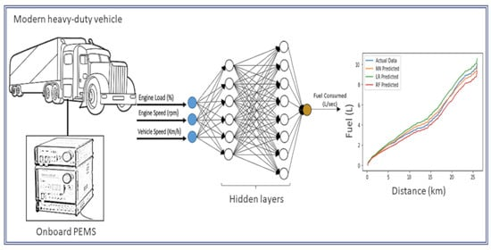

By,

SERENE GLADYA G

SHARMILA DEVI K

SHERYL PRISCILLA J

SWETHAA R

SNEKA A